
proposal of ict lab
RESTAURANT / CAFÉ WEBSITES (URBAN BITES)

SUBMITTED BY : AJNEHA FATIMA
SUBMITTED TO : SIR MOEEN UD DIN
DATE: 3 DEC 2025

INTRODUCTION:
Urban Bites Restaurant wants to create a simple and user-friendly website that allows customers to explore the menu, learn about the restaurant, and contact the management easily. This website will improve customer experience and increase online visibility.
PURPOSE OF THE WEBSITE :
The main goals of this website are:

To provide customers with basic restaurant information (location, timings, contact).

To display the menu with prices.

To show the restaurant’s introduction and environment.

To offer a clean and easy webpage that loads fast and works on mobile devices.
SCOPE OF PROJECT :
The website will contain four main sections:

1. Home Page – Welcome message and restaurant banner

2. Menu Page – Food items with descriptions and prices

3. About Us Page – Restaurant history and values

4. Contact Page – Location, phone number, operating hours

It will be developed using:

HTML for structure

CSS for design

(Optional) JavaScript for interaction
Database (for future upgrade like reservations / online orders)

REQUIREMENTS:
Simple navigation bar

Responsive layout (works on phone and laptop)

Organized menu

Contact details

Clean and attractive color theme

TECHNIQUES:
Frontend: HTML, CSS

Database: MySQL (for storing information like orders or reservations)

Text Editor: VS Code / Notepad++ / Sublime

Browser: Chrome, Firefox, or Edge

CODE:
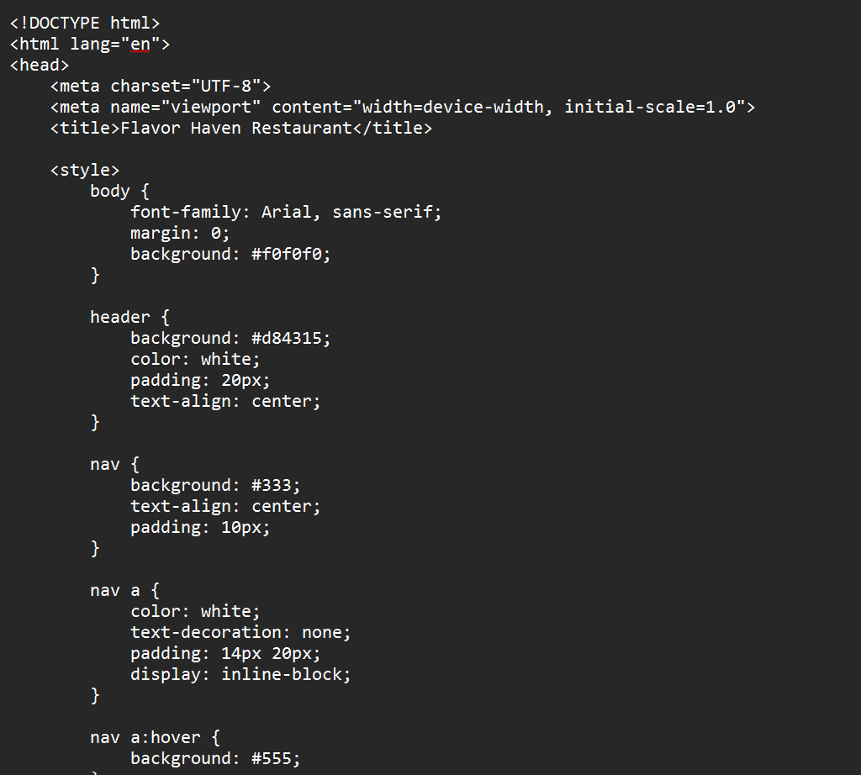

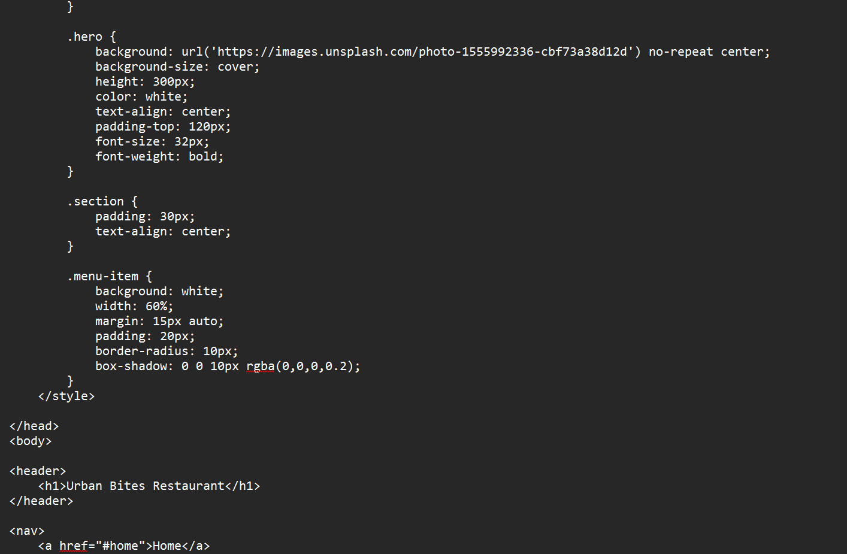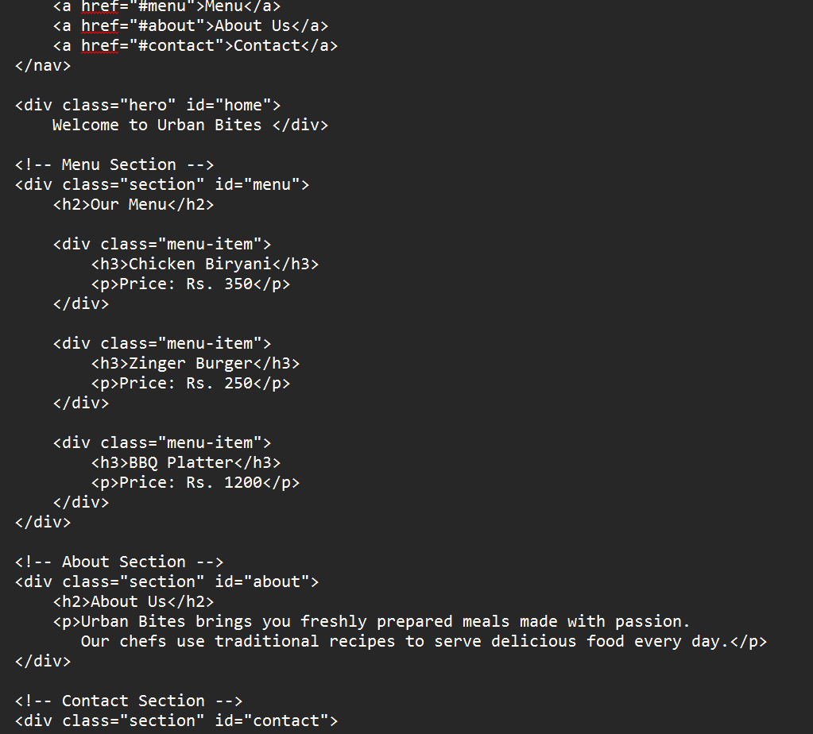
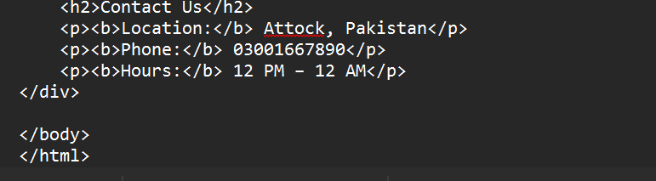

DATABASE:
(1) Customers Table
Field Name Type Description
customer_id INT (Primary Key) Unique ID
name VARCHAR(50) Customer name
phone VARCHAR(20) Phone number

(2) Menu Table
Field Name Type Description
item_id INT (Primary Key) Unique ID
item_name VARCHAR(50) Food name
price INT Food price

